## 

## Faterdenvermazonalanaus

## t ServiceUp

Demo date:   
Scoping start date: Nov 6, 2023

MSA Signature Date: Feb 7, 2024  
Onboarding Kick Off Date: Feb 7, 2024  
Go Live Date: Feb 7, 2024

GTM POC: Jarrett  
Implementation POC: Ariel

ERP: QBO

Tax Integration: Otherƒ

### 

### Key people at Merchant

### Accountant: [Caitlyn Mendenhall,](https://www.linkedin.com/in/caitlyn-mendenhall/overlay/about-this-profile/)([caitlyn@serviceup.com](mailto:caitlyn@serviceup.com)_)

### VP of Finance: David Holtzman (david@serviceup.com)

### Customer service rep who is really involved: Unknown

* Account Receivable POC: Unknown
* Billing POC: Unknown (Likely Caitlyn)
* etc.

### Company summary

They built a platform for fleet repairs. Companies can use their site to order repairs on a fleet vehicle, and they coordinate the full pick up/repair/drop off of the vehicle. Fleets pay them, they pick the car up, get it repaired, and take the spread between their charge to the fleet owner and the cost of the repair shop.

AM Notes

Any important relationship information  
  
1) What is Merchant Temperament?  
2) Is there key POC the buyer/decision maker? Unsure   
3) What are the Tabs features the key POC care about?

* AR Automation
* Could use remittances but hasn’t expressed interest

### Key People

* Caitlyn Murdick: Accounting Manager, main POC for project management during implementation, day-to-day decision maker
* Renee Rojas: Outsourced AR, lives in Tabs, sends all invoices daily, support requests
* David Holtzman: Main decision maker, Caitlyn’s boss

### Billing model

* Once a vehicle is repaired, the repair shop sends ServiceUp totals, and an invoice is generated from those repair line items
* Once the SU invoice is paid, they remit the money back to the shop (might want to use remittances for this in the future, this is currently done through Bill.com)
* Discounts are often applied to certain customers
* Have some customers that operate in different states (customer/sub-customer model?)

### Contract Processing Steps

General Process:

* They send ROs produced by their system to Tabs
* Tabs processes these ROs based on a set of rules in MIS
* These get sent from Tabs, sync to QBO
  + Some are not sent directly to the customer (AP portal, other preferences
  + For these, the ‘Bill Merchant’ setting is on in Garage

ServiceUp has a high volume of documents that will come in each week. Each customer has an MSA, and will then have subsequent documents, called Repair Orders (ROs) that come in each day.

MSA will include:

* Payment terms
* Service Term
* Recurring fees (if applicable)
* **Things to ignore in MSA:**
  + **Discounts**
  + **Credits**
  + **Commission structures**
  + **State based fees**

***These are all encompassed in the ROs, and do not need to be processed at BTs

**ROs will include:**

* **Customer name**
* **Date**
* **Billing line items**
* **Location (if applicable)**
* **Tax (if applicable)**
* **RO#**

**All customer creation comes from contracts with no repair order. If the RO does not match a customer, flag to GS for approval.**

Steps to process ROs:

1. Refer to the **Company Name** to find the name of the Customer and the **Date** to find the start date.
   1. Each of these ROs represents a moment in time, so this will be the start state of both the revenue schedule and the billing term, and it will be a single occurrence.
      1. Date frequency: **1 invoice per every None periods**
      2. Company Name Processing Detail. For customers below, please always use the name on the RIGHT :
         1. Zipcar Always Use: **Zipcar Inc**
         2. Sixt Always USe: **Sixt Rent a Car LLC**
         3. Clearcover Insurance Always Use: **Clearcover**
         4. Voyager Always Use: **Voyager Global Mobility3973bf86-1b48-4d7e-acdf-00a54973af5e**
         5. Kyte Systems Inc: Always use Kyte Systems Inc (Do Not Use “Kyte (Customer)”)
         6. **CHANGE 7/1/2025** Park N Fly and The Parking Spot are the same customer. Always use “The Parking Spot” (Do Not Use “Park N Fly”)

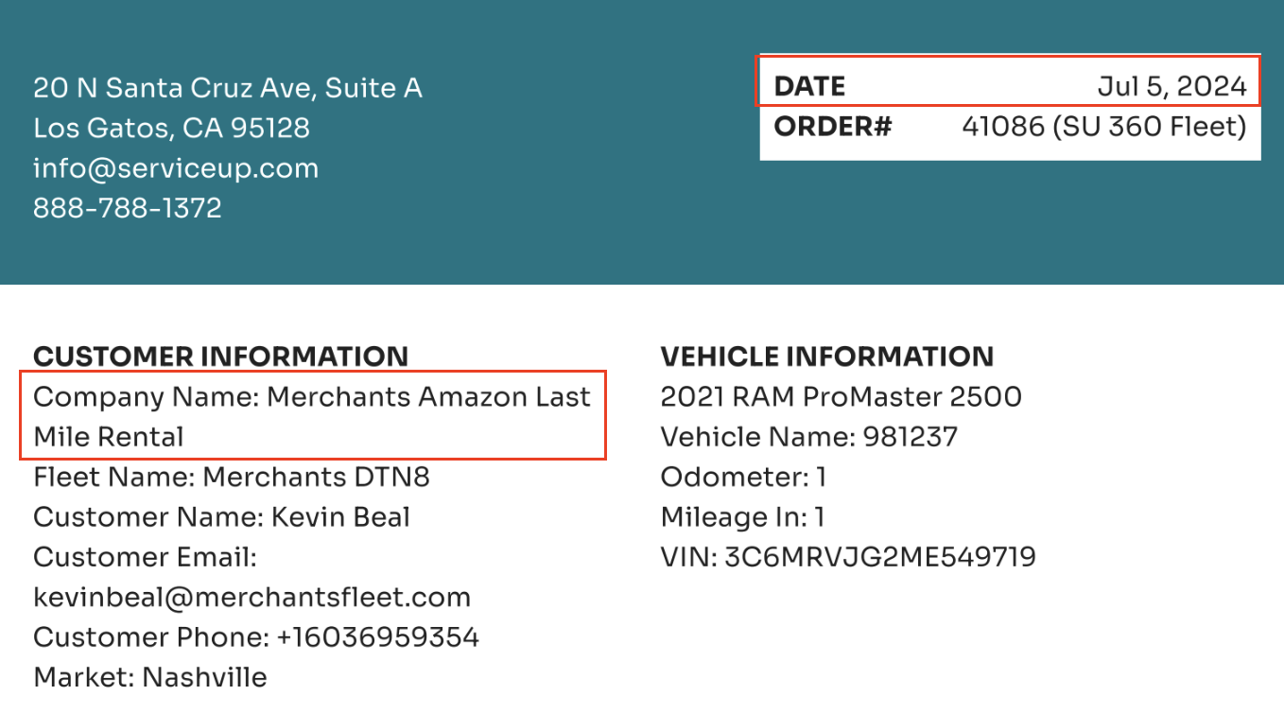

1. Refer to the line items in the RO for the billing terms.
   1. Use the table below (also found in [this sheet](https://docs.google.com/spreadsheets/d/1QAFx03joUYmGx5hY9TMYUBN0Fziqky_8/edit#gid=1180216922)) for BT name/description.
   2. **Item name should = Tabs Invoice Line Item Title**
   3. **NO description**

[**IF ITEMS ARE NOT FOUND BELOW, USE THIS SHEET TO SUPPLEMENTAL ITEMS**](https://docs.google.com/spreadsheets/d/1xdIXGYH0i1y-q5if6fljl1MmZgzleaSNTh9EGGOJ_pc/edit?gid=0#gid=0)

**\*\*\*UPDATE: If an item is not found on either list, look to see which column on the invoice it is in. If it is in the PARTS column, it can be linked to Parts Revenue**

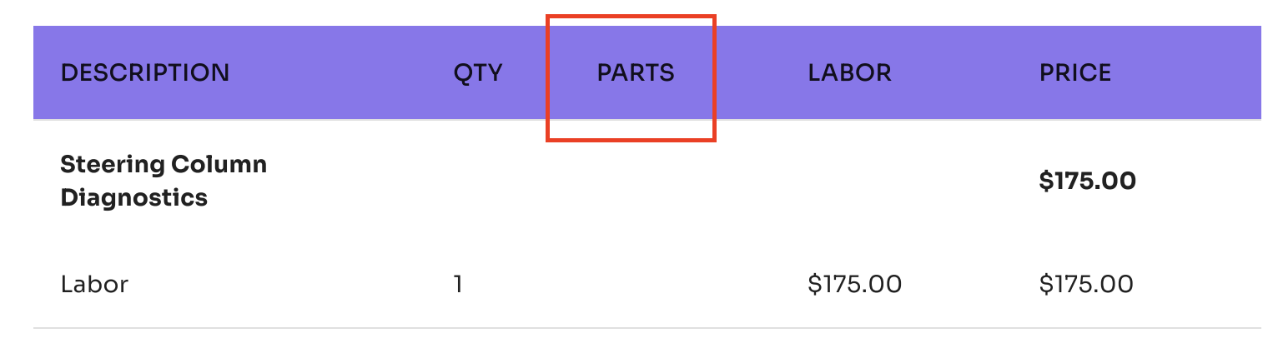

**\*\*\*\*UPDATE: If an item is not found on any of these sheets and cannot be assume based on closeness with other items on the list, PLEASE LEAVE BLANK  
  
***UPDATE 2: Never use the integration item: Labor Revenue: Labor Revenue - Use "Mechanical Labor" - make sure the mechanical labor that is selected is a "product" or "service" NOT a category**

| Platform | **PDF Naming Convention** | **Tabs Invoice Description** | **QBO Product/Service Mapping** |  |
| --- | --- | --- | --- | --- |
| SU 360 | body | Body Labor | Body Labor Revenue |  |
| SU 360 | Body Labor | Body Labor | Body Labor Revenue |  |
| SU 360 | Pre-tax discount | Discount | Discounts |  |
| SU 360 | mechanical | Mechanical Labor | Mechanical Labor Revenue |  |
| SU 360 | Mechanical. Labor | Mechanical Labor | Mechanical Labor Revenue |  |
| SU 360 | Misc. | Miscellaneous | Miscellaneous Labor Revenue |  |
| SU 360 | miscellaneous | Miscellaneous | Miscellaneous Labor Revenue |  |
| SU 360 | Fees & Hazardous Materials | Miscellaneous | Miscellaneous Labor Revenue |  |
| SU 360 | refinish | Paint Labor | Paint Labor Revenue |  |
| SU 360 | Paint Labor | Paint Labor | Paint Labor Revenue |  |
| SU 360 | paintMaterials | Paint Supplies | Paint Supplies |  |
| SU 360 | Paint Supplies | Paint Supplies | Paint Supplies |  |
| SU 360 | Parts | Parts | Parts Revenue |  |
| SU 360 | Parts & Fluids | Parts | Parts Revenue |  |
| SU 360 | Rebate | Rebate | Rebate |  |
| SU 360 | Tow - One Way | Towing | Towing |  |
| SU 360 | Sales Tax | Sales Tax | Sales Tax (AZ) | Phoenix |
| SU 360 | Sales Tax | Sales Tax | Sales Tax (CA) | Los Angeles, San Diego, SF Bay Area, West LA |
| SU 360 | Sales Tax | Sales Tax | Sales Tax (CO) | Denver |
| SU 360 | Sales Tax | Sales Tax | Sales Tax (DC) | Washington DC |
| SU 360 | Sales Tax | Sales Tax | Sales Tax (GA) | Atlanta |
| SU 360 | Sales Tax | Sales Tax | Sales Tax (IL) | Chicago |
| SU 360 | Sales Tax | Sales Tax | Sales Tax (MA) | Boston |
| SU 360 | Sales Tax | Sales Tax | Sales Tax (NC) | Raleigh, Greensboro |
| SU 360 | Sales Tax | Sales Tax | Sales Tax (NJ) |  |
| SU 360 | Sales Tax | Sales Tax | Sales Tax (NV) | Las Vegas |
| SU 360 | Sales Tax | Sales Tax | Sales Tax (NY) | New York |
| SU 360 | Sales Tax | Sales Tax | Sales Tax (PA) | Philadelphia, Pittsburgh |
| SU 360 | Sales Tax | Sales Tax | Sales Tax (TN) | Nashville |
| SU 360 | Sales Tax | Sales Tax | Sales Tax (TX) | Dallas, Houston, San Antonio, Austin |
| SU 360 | PainSales Tax | Sales Tax | Sales Tax (UT) | Salt Lake City |
| SU 360 | Sales Tax | Sales Tax | Sales Tax (WA) | Seattle |
| SU 360 | Sales Tax | Sales Tax | Sales Tax (NM) | Albuquerque |
| SU 360 | Sales Tax | Sales Tax | Sales Tax (WI) | Milwaukee |
| SU 360 | Sales Tax | Sales Tax | Sales Tax (MO) | Kansas City, St. Louis |
| SU 360 | Sales Tax | Sales Tax | Sales Tax (IN) | Indianapolis |
| SU Connect | Parts | Parts | SU Connect - Parts |  |
| SU Connect | Labor | Labor | SU Connect - Labor |  |
| SU Connect | Tax | Sales Tax | SU Connect - Sales Tax |  |
| SU 360 | Oil and Filter Change | Mechanical Labor | Mechanical Labor Revenue |  |
| SU 360 | Oil Syn 5w20 Qt | Parts | Parts Revenue |  |
| SU 360 | Oil Filter | Parts | Parts Revenue |  |
| SU 360 | Fees & Hazardous Materials | Miscellaneous | Miscellaneous Labor Revenue |  |
| SU 360 | Unlock Vehicle and Retrieve Key | Mechanical Labor | Mechanical Labor Revenue |  |

* + 1. Description in BT = Description in Tabs column in sheet

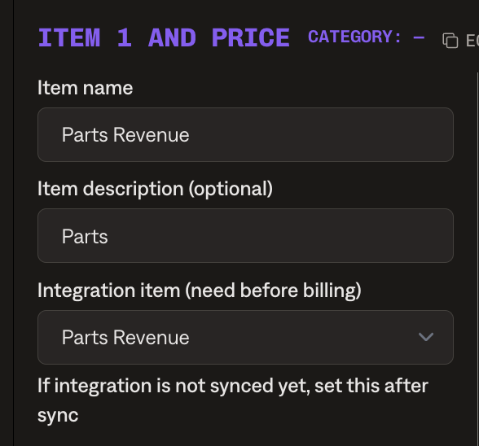

* 1. There are 2 types of taxable items: **SU Connect** and **SU 360**. This is identified next to the Order# on the top right of the RO. This dictates the integration items that are mapped to each item, which are listed in the above table.

*\*\*\*\*Make sure to link to the proper integration items based on which option is identified.*

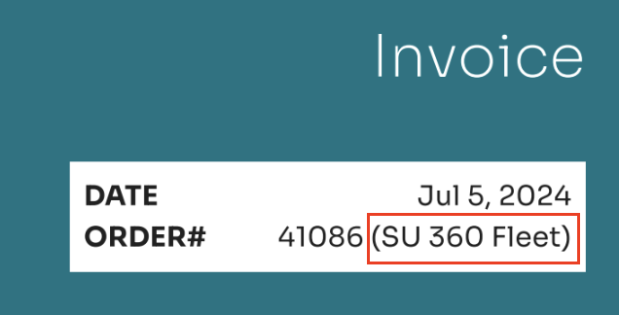

* 1. 0.00 SKUs do not need to be processed as BTs
  2. Ignore quantity for everything, Quantity=1 and process the totals.
     1. With the exception of Towing - show quantity for all towing line items
  3. Do not process bolded line-items
  4. Process discounts as negative BTs, they can take two different forms, both examples below.
     1. For the “Pre-tax discount” option, use the pre-tax discount integration item
     2. For the discounts with the same titles as the service provided, use the equivalent integration item (not the discount integration item)

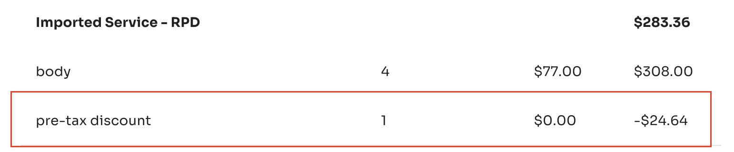

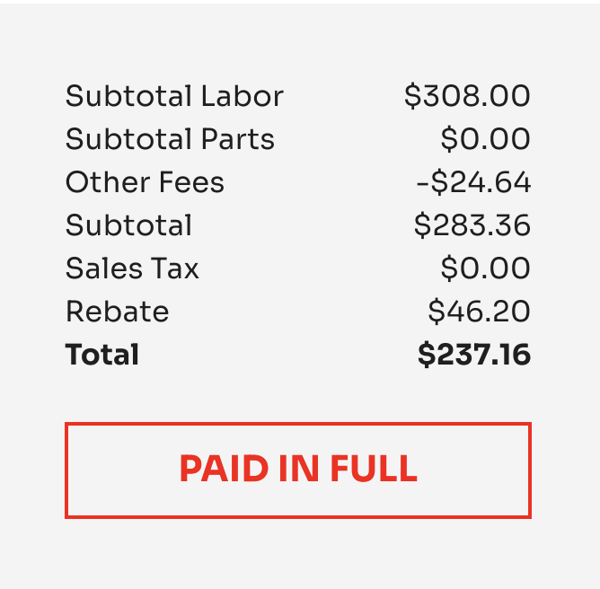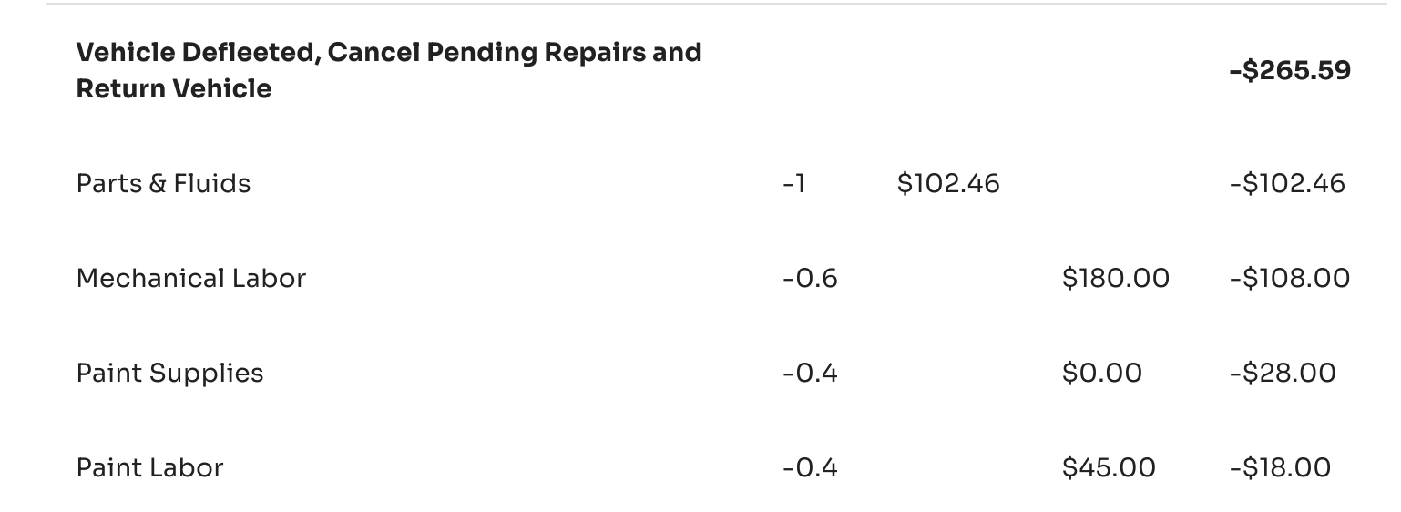

* 1. On all repair orders, there is a gray box with total at the bottom. Ignore **UNLESS**:
     1. **Rebate** is listed. If so, this will be a *negative* amount in the BT
     2. **Taxes** are listed. If so, process as billing terms.
        1. The integration item for Sales Tax will be associated with a state, and this state will be identified in the **Market** field in the Customer Information section at the top of the RO. This field will identify a city, which will be matched to a state. This is all reflected in the above table.
        2. If Market is listed, but the city is not listed in the above table, flag to [Ashni Walia](mailto:awalia@tabsplatform.com), and she will advise on which state to use.

1. Once all BTs are entered, move to the **Invoices** page. There are 3 fields that need to be populated from this page:
   1. Location
      1. This is identified via the **Market** field in the Customer Informations section at the top of the invoice (image above)
      2. To populate this field, go to the Action dropdown in the Invoices table, select **Edit additional fields**, and then select the city identified in the RO.
      3. If Fleet Name includes “Austin” the market is “Texas”
      4. SU Connect documents **DO NOT** require mapping to a market
   2. Odometer
      1. This is identified via the **Odometer** fields in the Customer Information section at the top of the invoice
      2. Copy the values of this field and enter into the **Odometer** field also found in the **Edit additional fields** section of the invoice.
   3. VIN
      1. This is identified via the **VIN** field in the Customer Information section at the top of the invoice
      2. Copy the values of this field and enter into the **VIN** field also found in the **Edit additional fields** section of the invoice.

Images below of ServiceUp document

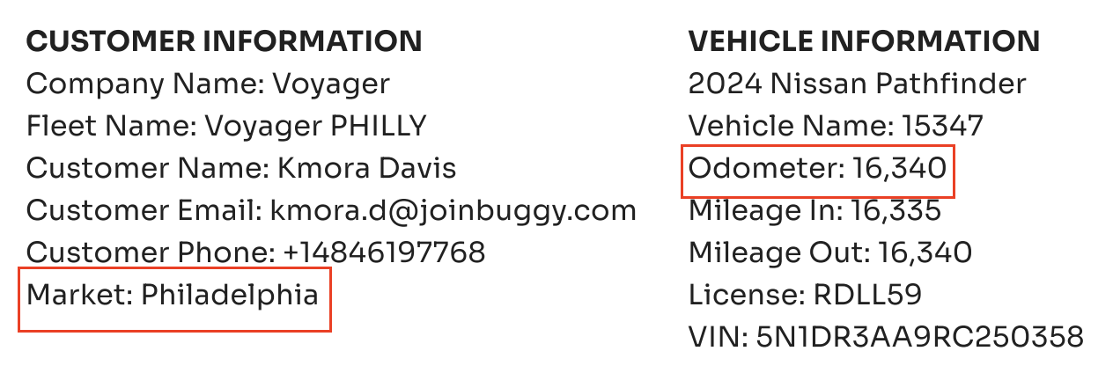

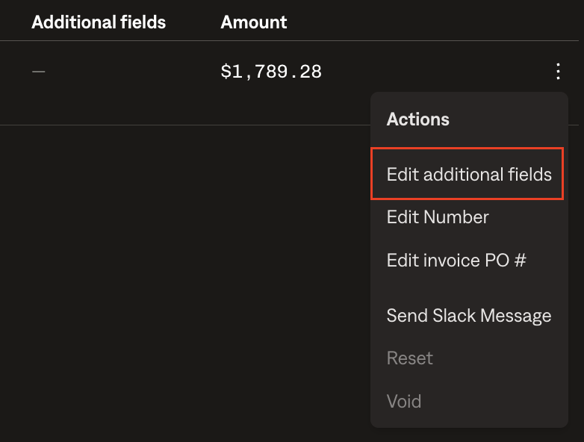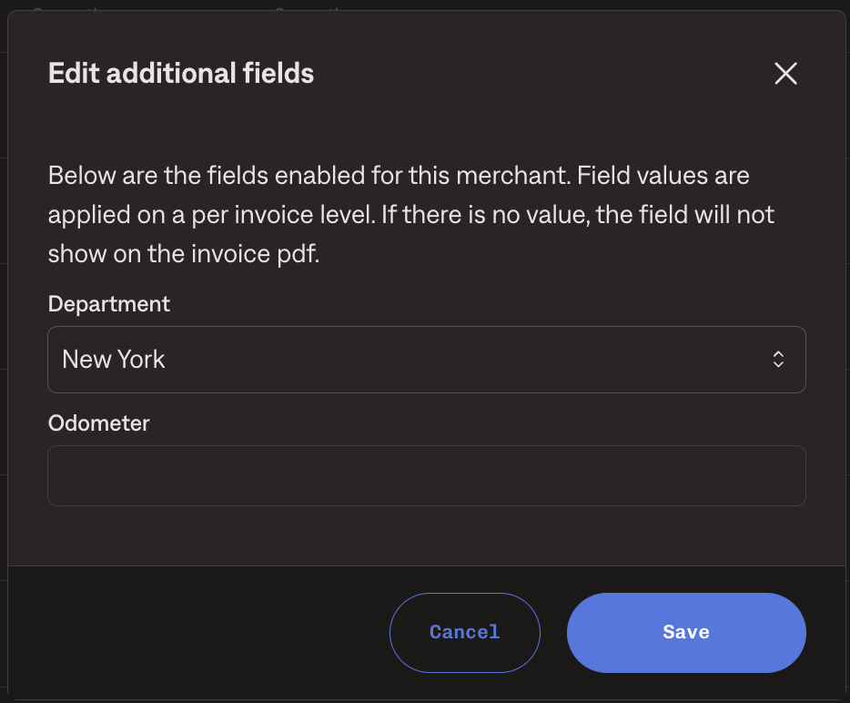

* 1. Invoice Number
     1. All invoices are required to be the same number as the RO number. Refer to the RO number on the top right of the RO document to find this value.
     2. To adjust this field, go to the Actions dropdown in the Invoices table, select **Edit Number** and type in the RO number identified in the RO.
     3. **Duplicates***:*
        1. When SU uploads a contract for the second time - and the billing terms are not identical, process both contracts. Please place a leading zero in front of the second contract's associated invoice. IE: RO123 is uploaded twice with different terms, process Invoice 123 AND invoice 0123. Service up will void the contract that is not correct.
        2. If invoice number already exists (Ie: Service Up has uploaded an identical RO to one tabs has already processed - please create the invoice with a leading zero, or zeros.) Example below:
           1. SU uploads RO 1234
           2. Tabs processes INV 1234
           3. SU Uploads RO 1234 (2) (or any other naming convention)
           4. Tabs processes INV 01234
           5. SU Uploades RO 1234(3) (or any other naming convention, this is to show if the RO is uploaded a 3rd time.
           6. Tabs Processes INV 001234
        3. 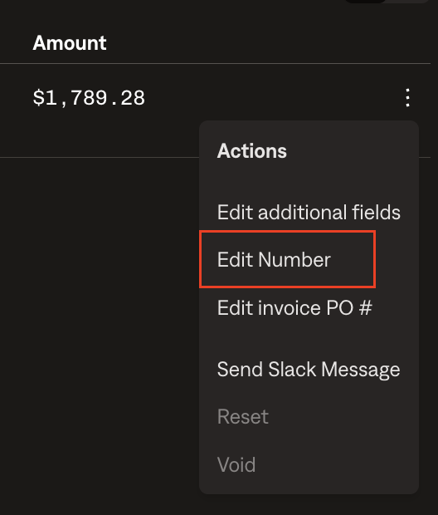amazon

**Customer Specifics:**

The name of the customer will be held within the title of the repair order in most cases, but will not be an exact match. Two of these nuances are:

1. Customer: **Kyte Systems Inc** with sometimes come in as some like **“39521, Kyte SF”** - use the word “Kyte” in the title as a signal to map to Kyte
2. Customer: **Voyager Global Mobility**
   1. sometimes come in as **Fast Track Leasing LLC** - map to “Voyager Global Mobility”
   2. Sometimes come in as “Voyager” - map to “Voyager Global Mobility”
   3. If there is a RO with voyager and ops is not clear how to process, please reach out to CX before creating a new client with the name “voyager”
3. Customer: **Hyrecar** should be mapped to **Getaround**
4. Customer: **Apple** should be mapped to **Doneln - Apple**
5. Customer: **IndieCampers** should always have net terms as **net 15**
6. **Town & Country vs Town & Country Couriers LLC: Please only use ​Town & Country Couriers LLC**
7. **Native Campervans, LLC**

* On all SU Connect invoices, we will want to add 1.99% fee. This should be calculated on the total invoice amount including tax, and can be mapped to "Transaction Fees."
* On SU 360 invoices, we will not want to add that fee. We will process that as normal

**Customer Specifics for Discounts**

Specific discounts are needed for certain items for certain customers according to the list below. When ROs for these customers come through, follow the instructions below:

| **Customer** | **Discount** | **Additional Discount** |
| --- | --- | --- |
| Apple | No Discount | No Discount |
| Nexgen | 4% |  |
| Hotwire Communications | 5% |  |
|  |  |  |
| BluSky | 4% |  |
| Traffic Management LA | 4% |  |
| Airport Van Rental | 4.35% | $0.95 |
| Acertus | 10% |  |
| DHI2 Element Last Mile Rental | 10% |  |
| Amazon Last Mile Rental (Amazon LMR)  ***Only for *Amazon LMR* - do not apply a discount to *Merchants* Amazon Last Mile Rental | 10% |  |

To process discounts:

1. If a discount is needed per the above requirements, a new line item will need to be added. This item should be:
   1. Invoice TOTAL*discount
   2. Ex: Invoice total = 600, Discount = 3%
      1. 600*.03=18
      2. Discount line item = -$18.00
2. For Apple and Airport Van Rental, there is also an extra BT that needs to be created for each of those transactions
   1. Apple: -$0.92 discount
   2. Airport Van Rental: -$0.95
3. Integration item for both of the above discounts should be: **Discounts**
4. Calculation sheet [here](https://docs.google.com/spreadsheets/d/1UY28LbxkJNYdQ_PmehvRwNpuzyQmLG7KVQCv-qcjef4/edit?gid=1408319687#gid=1408319687)

**Defaults:**

1. Default Service Term
   1. ROs do not need service term/period
2. Default Net Payment Terms
   1. Default all to Net 30
3. Default Billing Frequency
   1. N/A
4. How do we handle taxes as a line item?
   1. Per above instruction, if taxes are shown in RO, process at BT

Integration Items Processing (if necessary)

* What are the instructions for assigning integration items?
  + Integration items that correspond with each item within an RO are mapped out in [this document](https://docs.google.com/spreadsheets/d/1QAFx03joUYmGx5hY9TMYUBN0Fziqky_8/edit#gid=1180216922) and found in table above

Post Processing Communications (if necessary)

* Does Ops Team need to notify anyone on the team re: completion of processing batches in Implementation or Active phase?
  + None
* Who needs to be notified and when?
  + None

### Customer Information

* Use TaxJar for taxes, which is not integrated in their QBO. We process taxes at BTs
* They have one customer - Zipcar - that does NOT want to be receiving dunning emails.

### Features Built

* Class field automation
* Location field processing and on invoice
* Attached contract to invoice email and merge PDFs
* Custom fields

### Support issues

* From SU to Tabs:
  + **Customer/Integration time does not exist**: Once in a while this will show on an invoice for them. It means that the customer was likely mapped to the wrong customer record in garage during processing (such as a deleted customer or a Tabs customer). If this happens, you can adjust in garage and flag to Ashni to let her know of the error.
  + **Mistakes/Questions**: Sometimes she makes mistakes, such as marking as paid by mistake (rare) or sending an invoice that was not correct. Now she can reset and resend the invoice in Tabs, which she knows how to do but sometimes needs to be reminded.
* From Tabs to SU:
  + **Duplicate document**: if we catch them, we delete. No need to tell SU
  + **Market not listed**: This means that an RO with Sales Tax does not have a Market listed, which means we do not know which integration item for Sales Tax to use. If this happens, reach out to SU to ask which Market to use.
    - This happens because Market is not a required field for their team members to complete when closing out an RO on their side. They are trying to be more prescriptive internally to enforce everyone to fill this out, so it happens less. However, it still happens sometimes.
  + **Account period closed**: Invoice did not send because the account period was closed. For this, let SU know and then tell them to reset and resent once they re-open the period
  + **Duplicate invoice number**: Invoice did not send or invoice # cannot be updated during processing because of a duplicate invoice number. This means that they already sent the invoice in QBO, so that RO # already exists. If this happens, flag this to SU to confirm we can delete the contract on our side
    - This rarely happens anymore since they transitioned out of invoicing from QBO
  + **Integration item not found**: this is no longer an issue, we leave them blank now. No need to tell SU

### Rewatch Calls

* Can be [found here.](https://tabs-7so1666.slack.com/archives/C06RWAN42NP)